Table of Contents
Activity 1: Concept Review Questions 2
1. Differences Between Relational, Document-Based, and Graph-Based Databases 2
2. Scenarios Where MongoDB Is Better Suited Than a Relational Database 2
3. Key Components of a Graph in Neo4j and Their Significance 3
Activity 2: MongoDB Basics 3
1. Database and Collection 3
2. Sample Movie Documents 3
3. Retrieve Documents Using Filters 6
3.1 Find Movies by Genre 6
3.2 Find Movies by Release Year 6
3.3 Find Movies by Director 7
4. Update Nested Fields in Documents 8
4.1 Update Director Country 8
4.2 Add a New Cast Member 8
5. Aggregation Pipeline 9
5.1 Average Rating by Genre 9
6. Advantages of Using MongoDB 10
Activity 3: Introduction to Neo4j 10
1. Tool Used 10
2. Create the Social Network Graph 10
2.1 Clear Existing Data 10
2.2 Create Person and Interest Nodes 11
2.3 Display the Graph 12
3. Query 1: Retrieve All Friends of a Specific Person 13
Query 13
Expected Result 13
4. Query 2: Find People Who Like the Same Interest 13
Query 13
Expected Result 13
5. Query 3: Identify the Shortest Path Between Two People 14
Query 14
Expected Path 14
6. Short Discussion 15
Activity 4: Real-World Scenario 16
1. MongoDB Dataset: Product Reviews 16
1.1 Dataset in JSON Format 16
2. MongoDB Storage Approach 18
3. MongoDB Queries 19
3.1 Find Electronics Reviews 19
3.2 Find Reviews with Rating 4 or Higher 20
3.3 Find Reviews by User Location 20
3.4 Find Reviews Containing the Tag Wireless 21
3.5 Average Rating Grouped by Category 21
4. Neo4j Dataset: Transportation Network 22
4.1 Relationship-Focused Dataset 22
5. Neo4j Graph Model 23
5.1 Nodes 23
5.2 Relationships 23
6. Neo4j Cypher Script 23
6.1 Create Transportation Network 23
7. Neo4j Queries 24
7.1 Show the Full Transportation Graph 24
7.2 Find Cities Directly Connected to London 25
7.3 Find Shortest Path from London to Liverpool 26
7.4 Find Train Routes Only 27
7.5 Find Total Connections per City 27
8. Analysis 28

Activity 1: Concept Review Questions

1. Differences Between Relational, Document-Based, and Graph-Based Databases
Data is stored in structured tables with rows and columns in relational databases. They have a defined schema, which means that before entries are made, the data's structure must be determined. SQL is used by relational databases to query, insert, update, and delete data. They function effectively in systems like banking, payroll, and student records that demand a high level of regularity and well-organized links.
Data is stored in document-based databases as documents, often in a format similar to JSON. They don't need a rigorously specified schema, in contrast to relational databases. Different fields can be incorporated in each document, enabling them to react to changing data. One example of a document-based database is MongoDB. Applications with a range of data sorts, user profiles, content management systems, and product catalogs can all benefit from this form of database.
Data is stored as nodes and relationships in graph-based databases. Relationships indicate the links between nodes, which represent entities such as persons or products. Both nodes and relationships can have characteristics added to them. One example of a graph database is Neo4j. Densely connected data, like that found in social networks, recommendation systems, fraud detection, and network analysis, works well with graph databases.

2. Scenarios Where MongoDB Is Better Suited Than a Relational Database
MongoDB is superior to relational databases when the data is vast, adaptable, or subject to quick changes. In an e-commerce site, for example, different products could have distinct qualities. A laptop might feature CPU and RAM information, whereas clothes might have size and color fields. MongoDB can easily store these different product structures in documents without requiring a huge number of separate tables.
MongoDB is also excellent for applications that need to handle vast amounts of data and expand quickly. It is commonly used in real-time web applications, mobile applications, content management systems, product catalogs, and user profile management. Because MongoDB stores data in documents that resemble JSON, it is easier for developers to work with when creating modern apps.
Another instance is when linked data is often accessed simultaneously. For example, order summaries or address information may be provided in a customer record, which would remove the demand for complex joins. This can speed up and simplify queries compared to relational databases.

3. Key Components of a Graph in Neo4j and Their Significance
The core components of a Neo4j network are nodes, relationships, labels, attributes, and paths.
Nodes are used to represent database entities. In a social network, for example, each individual can be represented as a node.
Nodes are joined together and their connections are shown. One person may be related to another through a FRIENDS or FOLLOWS relationship, for example.
Labels are used to classify nodes. For example, a node may be labeled User, Product, or Company.
Properties offer information about nodes and relationships. For example, a user node may have attributes like name, age, and location.
The connections between nodes are illustrated by pathways. They are handy for finding routes, links, persons, or distances.
Because they allow Neo4j to efficiently represent and query linked data, these components are critical.

Activity 2: MongoDB Basics

1. Database and Collection
Database Name: movieDB
Collection Name: movies
Application Type: Movie database application
The movies collection stores movie records with fields such as title, genre, release year, rating, director information, and cast members.

2. Sample Movie Documents
The following JSON-like documents were inserted into the movies collection:

db.movies.insertMany([
{
title: "Inception",
genre: ["Sci-Fi", "Action"],
releaseYear: 2010,
rating: 8.8,
director: {
name: "Christopher Nolan",
country: "UK"
},
cast: ["Leonardo DiCaprio", "Joseph Gordon-Levitt", "Elliot Page"]
},
{
title: "The Dark Knight",
genre: ["Action", "Crime"],
releaseYear: 2008,
rating: 9.0,
director: {
name: "Christopher Nolan",
country: "UK"
},
cast: ["Christian Bale", "Heath Ledger", "Aaron Eckhart"]
},
{
title: "Interstellar",
genre: ["Sci-Fi", "Adventure"],
releaseYear: 2014,
rating: 8.6,
director: {
name: "Christopher Nolan",
country: "UK"
},
cast: ["Matthew McConaughey", "Anne Hathaway", "Jessica Chastain"]
},
{
title: "Parasite",
genre: ["Thriller", "Drama"],
releaseYear: 2019,
rating: 8.5,
director: {
name: "Bong Joon-ho",
country: "South Korea"
},
cast: ["Song Kang-ho", "Lee Sun-kyun", "Cho Yeo-jeong"]
},
{
title: "The Matrix",
genre: ["Sci-Fi", "Action"],
releaseYear: 1999,
rating: 8.7,
director: {
name: "Lana Wachowski",
country: "USA"
},
cast: ["Keanu Reeves", "Laurence Fishburne", "Carrie-Anne Moss"]
}
])
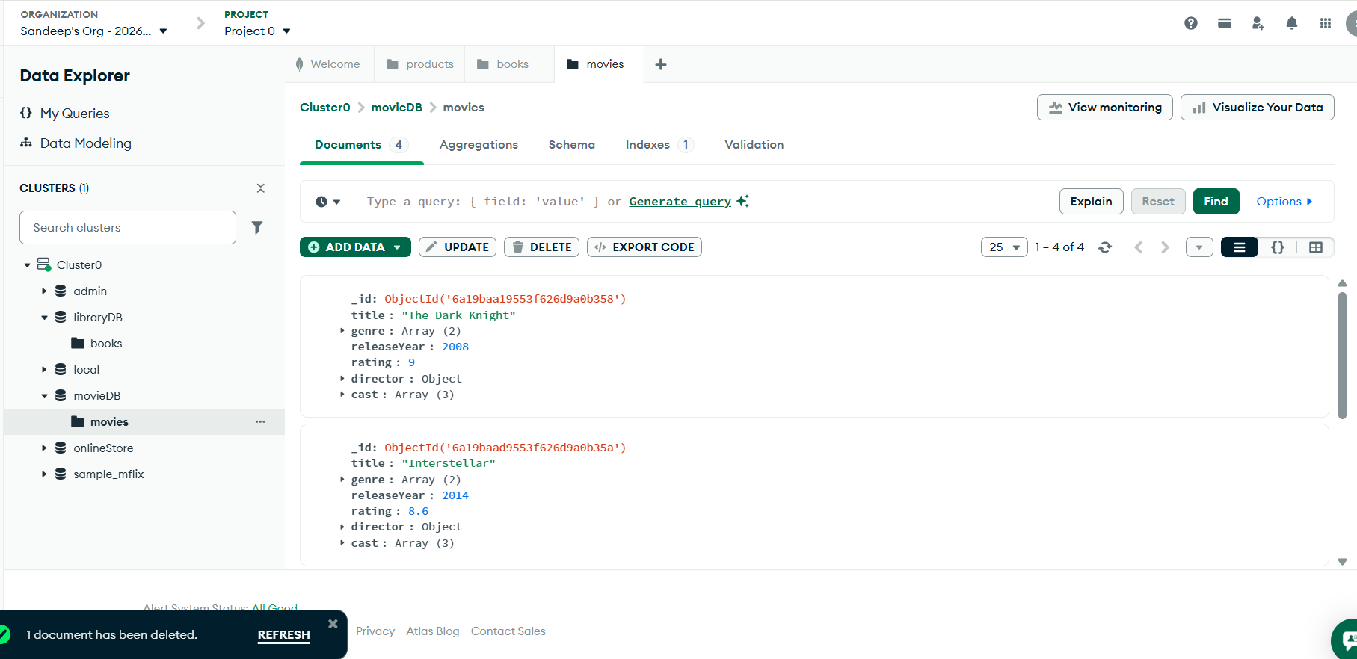

3. Retrieve Documents Using Filters

3.1 Find Movies by Genre
db.movies.find({ genre: "Sci-Fi" }).pretty()
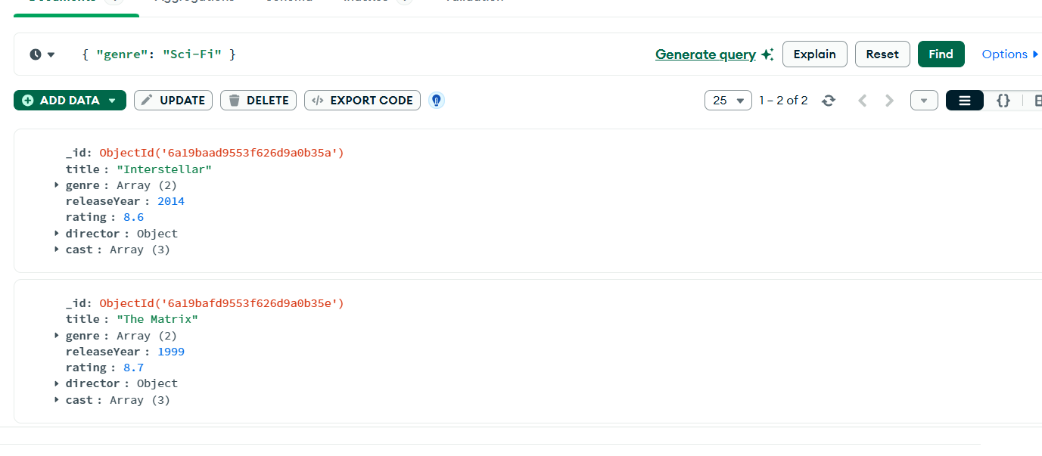

This query retrieves all movies that contain Sci-Fi in the genre array.

3.2 Find Movies by Release Year
db.movies.find({ releaseYear: { $gt: 2010 } }).pretty()
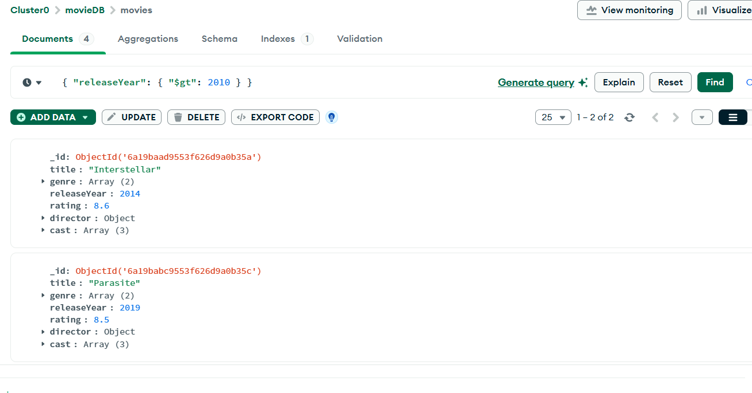
This query retrieves movies released after 2010.

3.3 Find Movies by Director
db.movies.find({ "director.name": "Christopher Nolan" }).pretty()
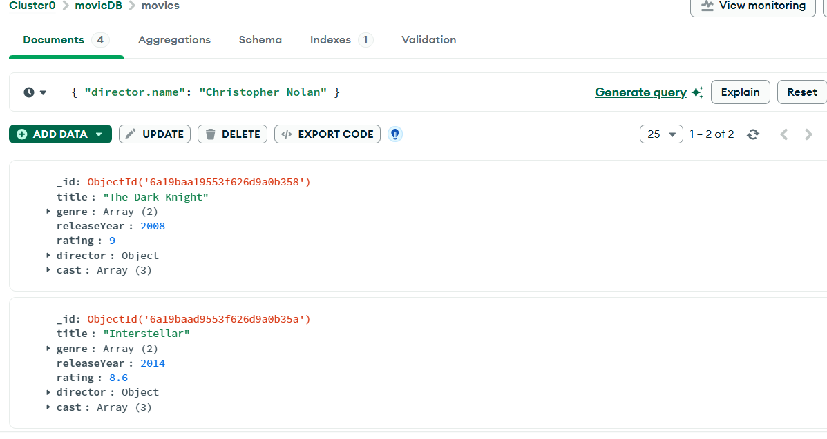
This query retrieves movies directed by Christopher Nolan.

4. Update Nested Fields in Documents

4.1 Update Director Country
db.movies.updateOne(
{ title: "The Matrix" },
{ $set: { "director.country": "United States" } }
)
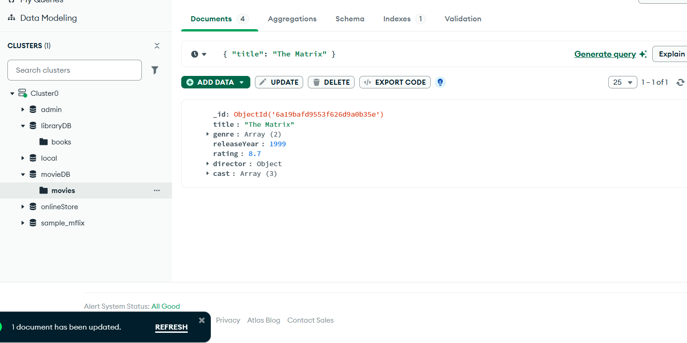
This query updates the nested field director.country for the movie The Matrix.

4.2 Add a New Cast Member
db.movies.updateOne(
{ title: "Inception" },
{ $push: { cast: "Tom Hardy" } }
)
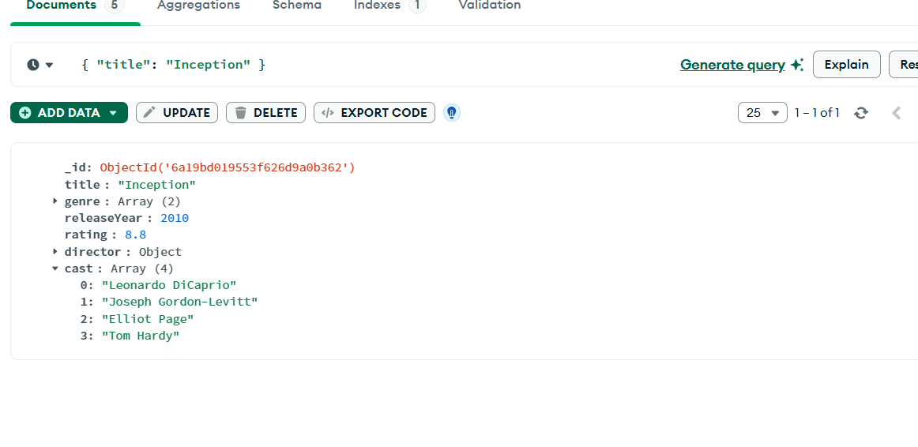
This query adds a new actor to the cast array of the movie Inception.

5. Aggregation Pipeline

5.1 Average Rating by Genre
db.movies.aggregate([
{ $unwind: "$genre" },
{
$group: {
_id: "$genre",
averageRating: { $avg: "$rating" },
totalMovies: { $sum: 1 }
}
},
{ $sort: { averageRating: -1 } }
])
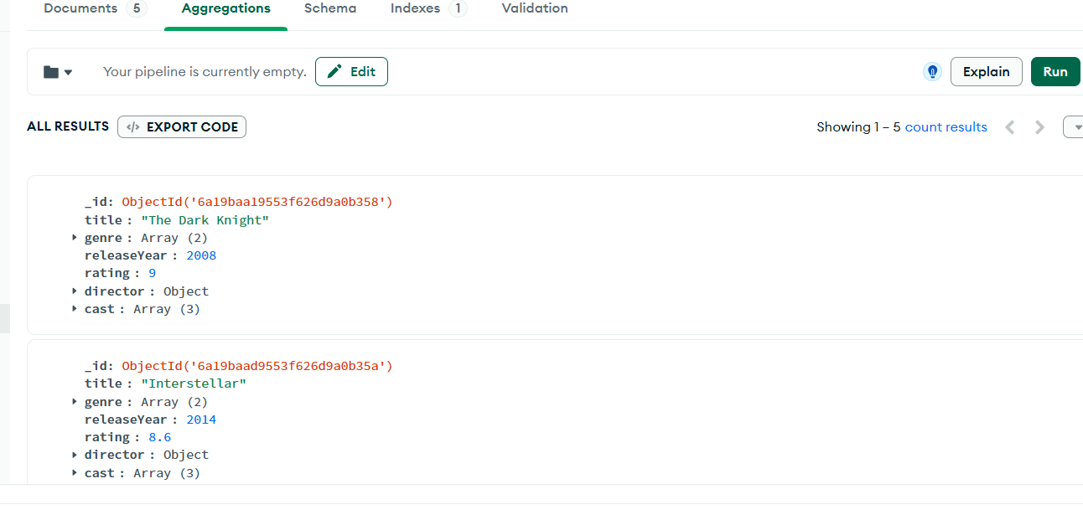

This aggregation pipeline separates each genre using $unwind, groups movies by genre using $group, calculates the average rating using $avg, and sorts the result from highest to lowest rating.

6. Advantages of Using MongoDB
MongoDB is useful for this movie database because it can store flexible JSON-like documents. The genre and cast fields are stored as arrays, while the director field is stored as a nested object. This makes MongoDB suitable for applications where data may have different structures.

Activity 3: Introduction to Neo4j

1. Tool Used
Tool: Neo4j Aura / Neo4j Sandbox / Neo4j Desktop
Database Type: Graph Database
Query Language: Cypher

2. Create the Social Network Graph

2.1 Clear Existing Data
Removing old data:
MATCH (n)
DETACH DELETE n;

2.2 Create Person and Interest Nodes
CREATE
(alice:Person {name: "Alice", age: 25, location: "New York"}),
(bob:Person {name: "Bob", age: 27, location: "Chicago"}),
(charlie:Person {name: "Charlie", age: 23, location: "Boston"}),
(diana:Person {name: "Diana", age: 29, location: "Seattle"}),
(ethan:Person {name: "Ethan", age: 31, location: "Denver"}),

(music:Interest {name: "Music"}),
(sports:Interest {name: "Sports"}),
(coding:Interest {name: "Coding"}),
(movies:Interest {name: "Movies"}),

(alice)-[:FRIEND]->(bob),
(bob)-[:FRIEND]->(alice),

(alice)-[:FRIEND]->(charlie),
(charlie)-[:FRIEND]->(alice),

(bob)-[:FRIEND]->(diana),
(diana)-[:FRIEND]->(bob),

(charlie)-[:FRIEND]->(ethan),
(ethan)-[:FRIEND]->(charlie),

(alice)-[:LIKES]->(music),
(bob)-[:LIKES]->(music),
(charlie)-[:LIKES]->(coding),
(diana)-[:LIKES]->(sports),
(ethan)-[:LIKES]->(coding),
(alice)-[:LIKES]->(movies),
(diana)-[:LIKES]->(movies);
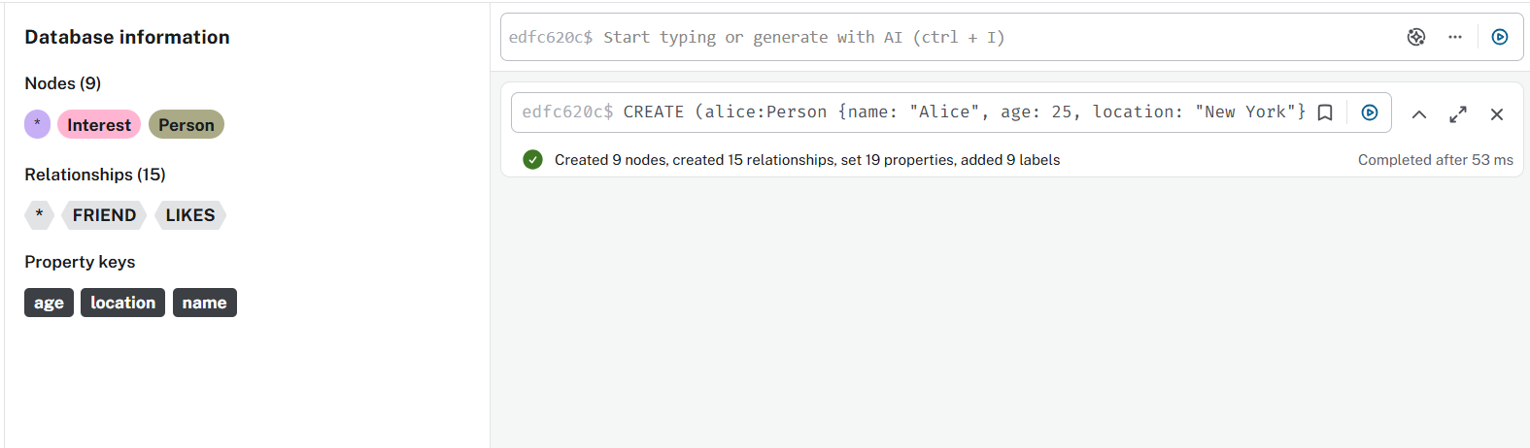

2.3 Display the Graph
MATCH (n)-[r]->(m)
RETURN n, r, m;
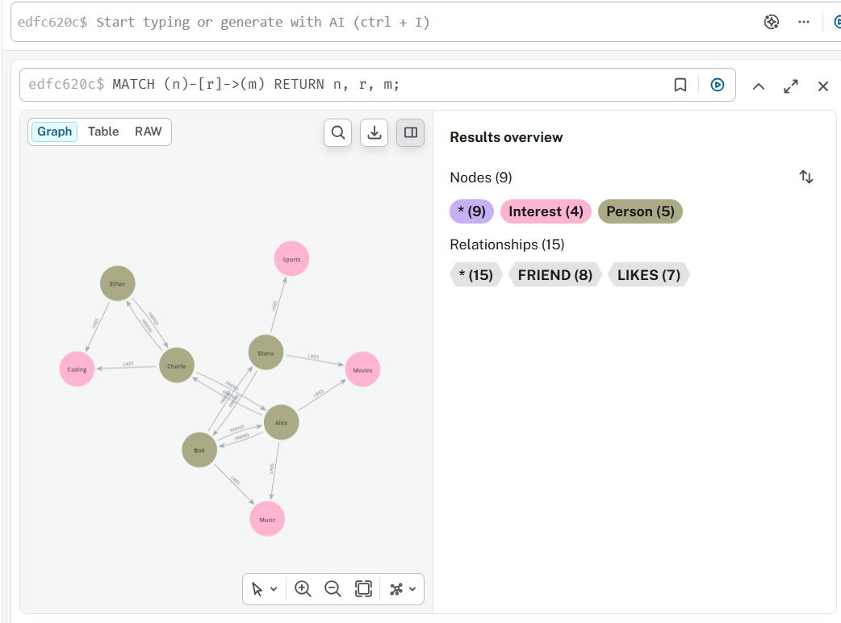

3. Query 1: Retrieve All Friends of a Specific Person

Query
This query retrieves all friends of Alice:
MATCH (p:Person {name: "Alice"})-[:FRIEND]->(friend:Person)
RETURN friend.name AS Friend, friend.age AS Age, friend.location AS Location;

Expected Result
Friend | Age | Location
Bob | 27 | Chicago
Charlie | 23 | Boston
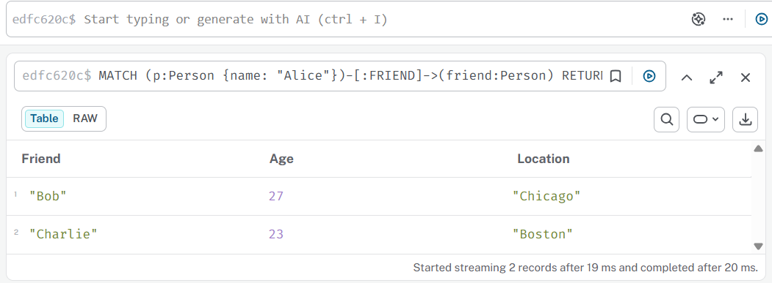

4. Query 2: Find People Who Like the Same Interest

Query
This query finds people who like the same interest as Alice:
MATCH (alice:Person {name: "Alice"})-[:LIKES]->(interest:Interest)<-[:LIKES]-(person:Person)
WHERE person.name <> "Alice"
RETURN person.name AS Person, interest.name AS SharedInterest;

Expected Result
Person | SharedInterest
Bob | Music
Diana | Movies

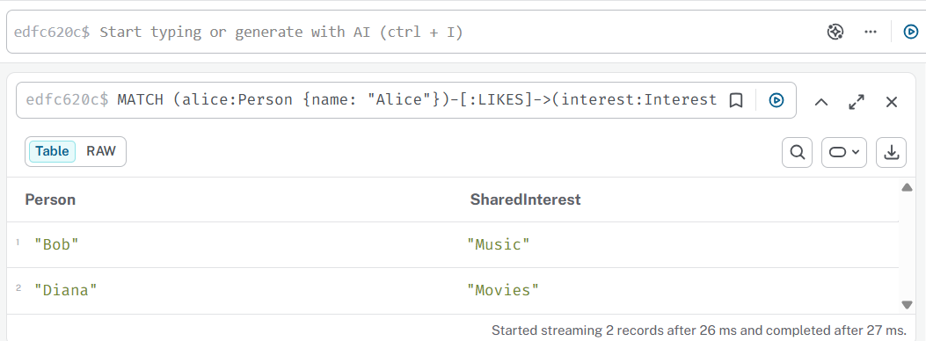

5. Query 3: Identify the Shortest Path Between Two People

Query
This query finds the shortest path between Alice and Ethan:
MATCH path = shortestPath(
(a:Person {name: "Alice"})-[:FRIEND*]-(e:Person {name: "Ethan"})
)
RETURN path;

Expected Path
Alice → Charlie → Ethan
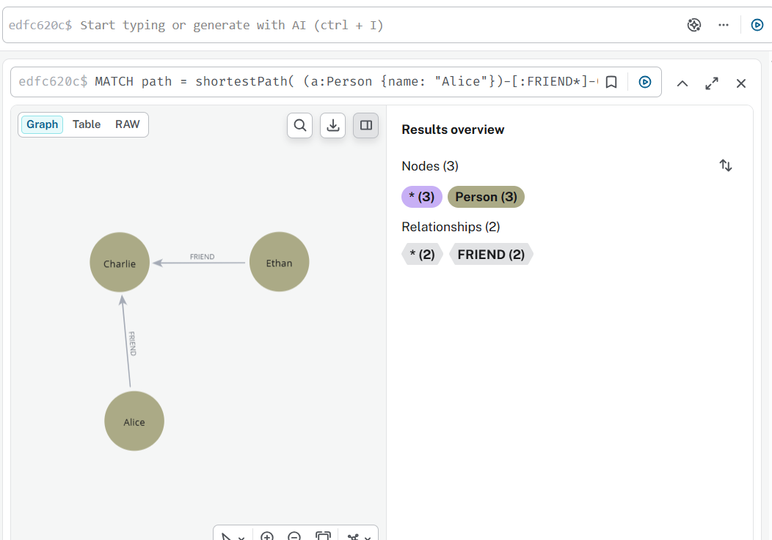

6. Short Discussion
Neo4j is useful for showing connected data since it preserves information as nodes and relationships. In this exercise, Person nodes represent people in a social network, while Interest nodes stand in for hobbies or themes. Friendships bond people together, and likes link people to their hobbies.
Graph databases are ideal for social networking applications because they can quickly locate friends, shared interests, suggestions, and connection paths. For example, Neo4j can discover people with similar interests or determine the shortest path between two users. Graph databases are therefore useful for social media, fraud detection, network analysis, and recommendation systems.

Activity 4: Real-World Scenario

1. MongoDB Dataset: Product Reviews

1.1 Dataset in JSON Format
[
{
"review_id": "R001",
"product_id": "P101",
"product_name": "Wireless Mouse",
"category": "Electronics",
"user": {
"user_id": "U001",
"name": "Alice",
"location": "New York"
},
"rating": 5,
"review_text": "The mouse is comfortable and works smoothly.",
"tags": ["comfortable", "wireless", "smooth"],
"verified_purchase": true,
"date": "2024-01-15"
},
{
"review_id": "R002",
"product_id": "P102",
"product_name": "Gaming Keyboard",
"category": "Electronics",
"user": {
"user_id": "U002",
"name": "Bob",
"location": "Chicago"
},
"rating": 4,
"review_text": "Good keyboard with bright backlight.",
"tags": ["gaming", "keyboard", "backlight"],
"verified_purchase": true,
"date": "2024-02-10"
},
{
"review_id": "R003",
"product_id": "P103",
"product_name": "Office Chair",
"category": "Furniture",
"user": {
"user_id": "U003",
"name": "Charlie",
"location": "Boston"
},
"rating": 3,
"review_text": "Comfortable chair but delivery was late.",
"tags": ["chair", "comfortable", "delivery"],
"verified_purchase": false,
"date": "2024-03-05"
},
{
"review_id": "R004",
"product_id": "P101",
"product_name": "Wireless Mouse",
"category": "Electronics",
"user": {
"user_id": "U004",
"name": "Diana",
"location": "Seattle"
},
"rating": 4,
"review_text": "Battery life is good and design is nice.",
"tags": ["battery", "design", "wireless"],
"verified_purchase": true,
"date": "2024-03-20"
}
]

2. MongoDB Storage Approach
The dataset was stored in MongoDB Atlas using:
Database: reviewDB
Collection: productReviews
Each product review was stored as one document. MongoDB is suitable for this dataset because it supports nested objects and arrays. In this dataset, the user field is a nested object, while the tags field is an array.

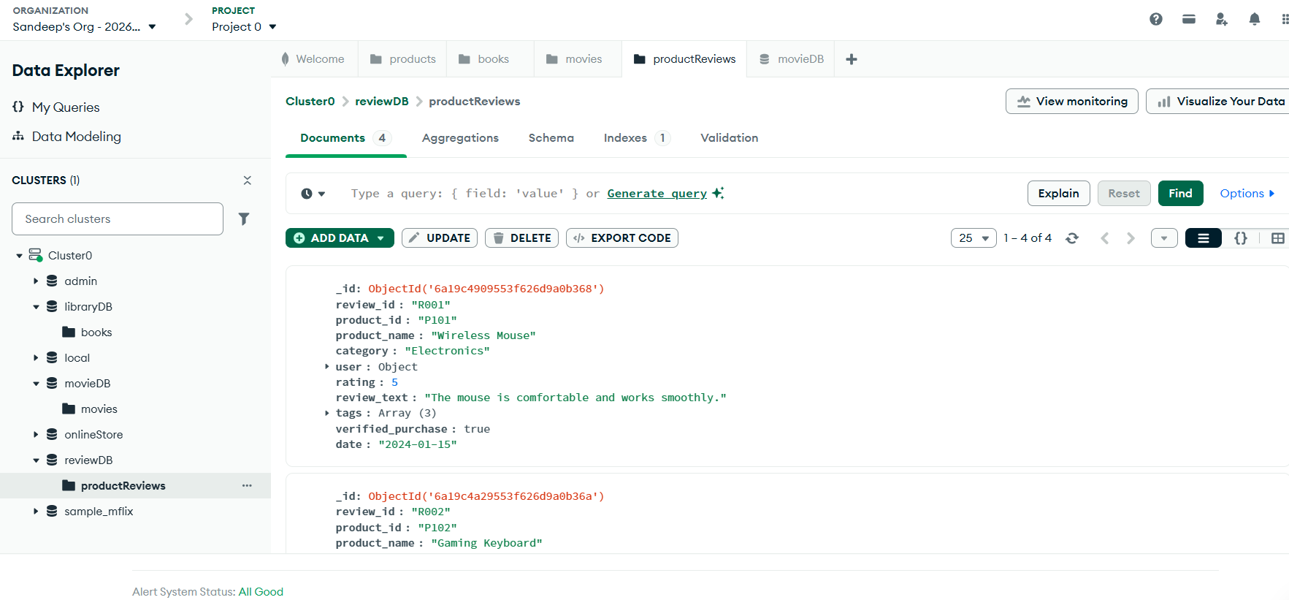

3. MongoDB Queries

3.1 Find Electronics Reviews
db.productReviews.find({ category: "Electronics" })

This query returned all product reviews in the Electronics category.

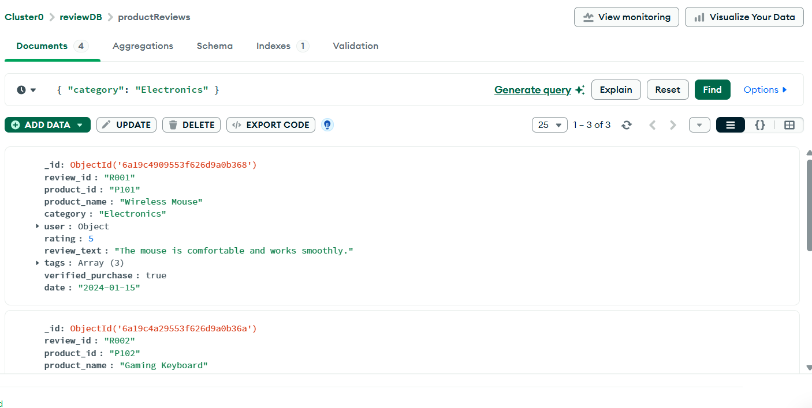

3.2 Find Reviews with Rating 4 or Higher
db.productReviews.find({ rating: { $gte: 4 } })

This query returned reviews where the rating was greater than or equal to 4.
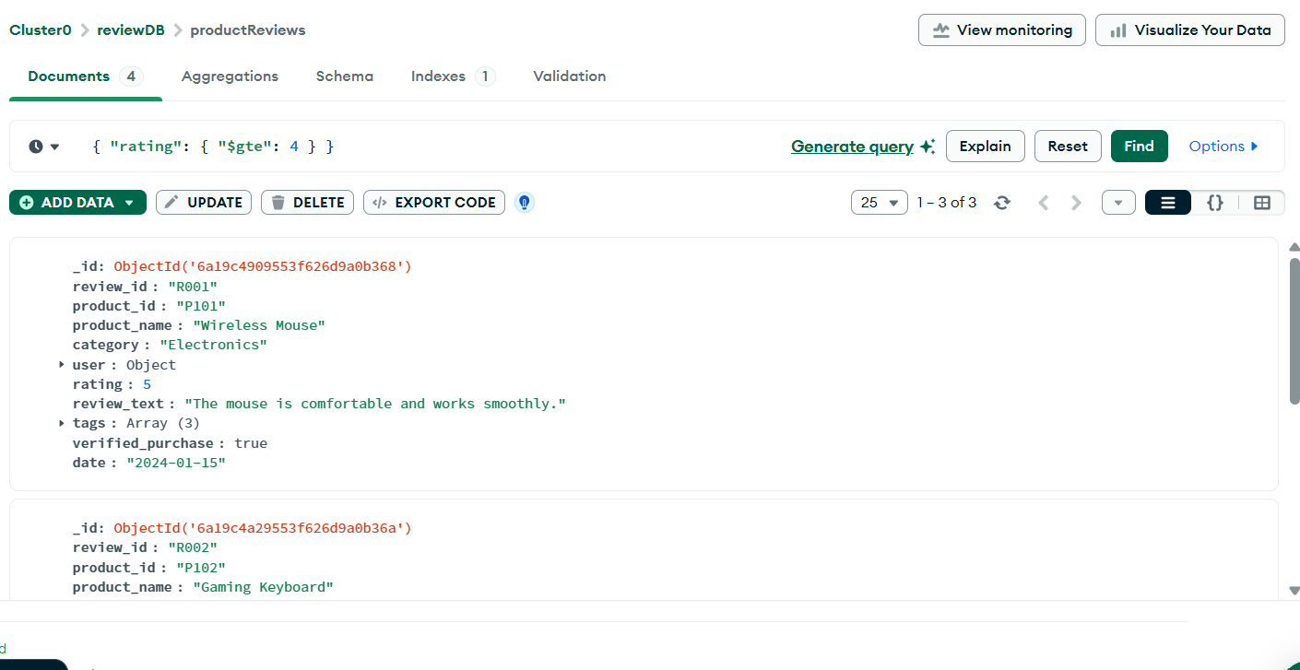

3.3 Find Reviews by User Location
db.productReviews.find({ "user.location": "New York" })

This query searched inside the nested user object and returned the review written by a user from New York.
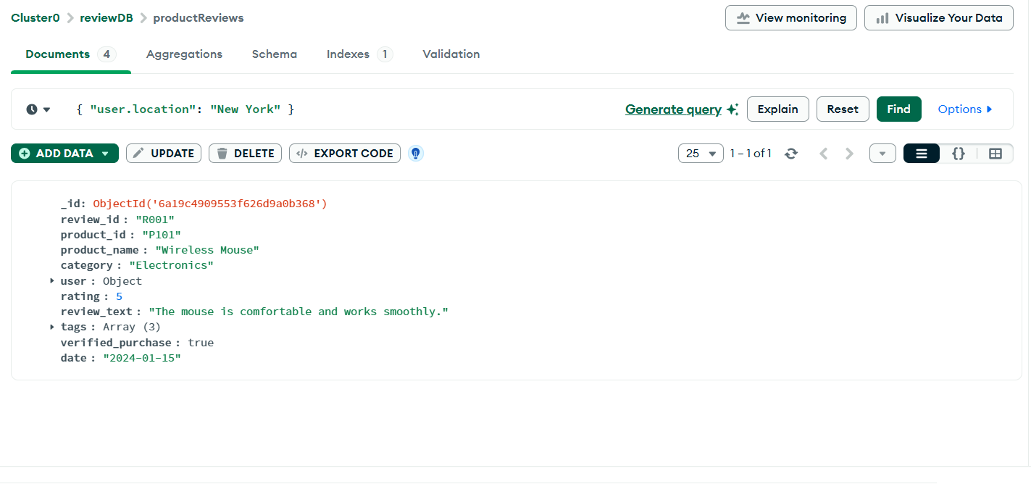

3.4 Find Reviews Containing the Tag Wireless
db.productReviews.find({ tags: "wireless" })

This query searched the tags array and returned reviews containing the tag wireless.
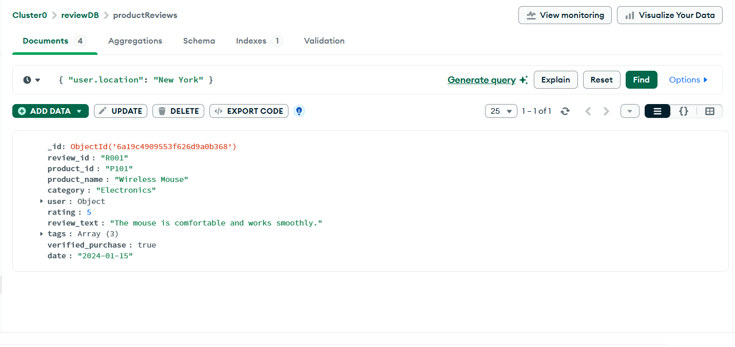

3.5 Average Rating Grouped by Category
db.productReviews.aggregate([
{
$group: {
_id: "$category",
averageRating: { $avg: "$rating" },
totalReviews: { $sum: 1 }
}
}
])

This aggregation grouped reviews by category and calculated the average rating for each category.
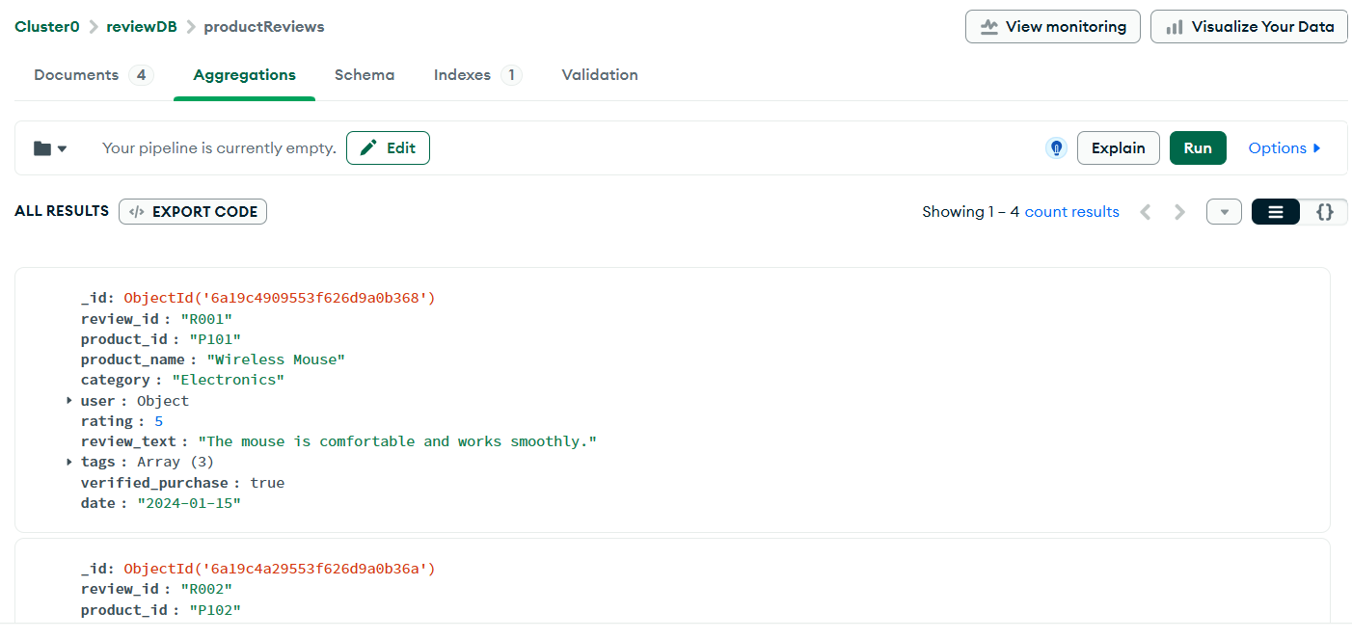

4. Neo4j Dataset: Transportation Network

4.1 Relationship-Focused Dataset
The relationship-focused dataset represents a transportation network between cities.
Cities:
- London
- Manchester
- Birmingham
- Liverpool
- Leeds
Routes:
- London connects to Birmingham
- Birmingham connects to Manchester
- Manchester connects to Liverpool
- Manchester connects to Leeds
- Birmingham connects to Leeds
- London connects to Leeds
Each route includes properties such as distance and transport type.

5. Neo4j Graph Model

5.1 Nodes
Each city was represented as a city node.
Example:
(:City {name: "London"})

5.2 Relationships
Each connection between cities was represented using a CONNECTED_TO relationship.
Example:
(:City {name: "London"})-[:CONNECTED_TO {distance: 160, type: "Train"}]->(:City {name: "Birmingham"})

6. Neo4j Cypher Script

6.1 Create Transportation Network
CREATE
(london:City {name: "London"}),
(manchester:City {name: "Manchester"}),
(birmingham:City {name: "Birmingham"}),
(liverpool:City {name: "Liverpool"}),
(leeds:City {name: "Leeds"}),

(london)-[:CONNECTED_TO {distance: 160, type: "Train"}]->(birmingham),
(birmingham)-[:CONNECTED_TO {distance: 140, type: "Train"}]->(manchester),
(manchester)-[:CONNECTED_TO {distance: 55, type: "Train"}]->(liverpool),
(manchester)-[:CONNECTED_TO {distance: 70, type: "Bus"}]->(leeds),
(birmingham)-[:CONNECTED_TO {distance: 120, type: "Bus"}]->(leeds),
(london)-[:CONNECTED_TO {distance: 195, type: "Train"}]->(leeds);
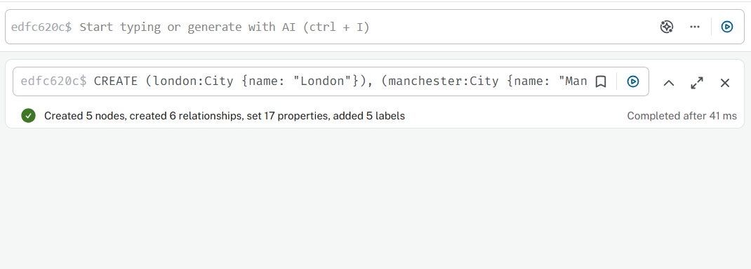

7. Neo4j Queries

7.1 Show the Full Transportation Graph
MATCH (c1:City)-[r:CONNECTED_TO]->(c2:City)
RETURN c1, r, c2;
This query displayed the full transportation network graph.
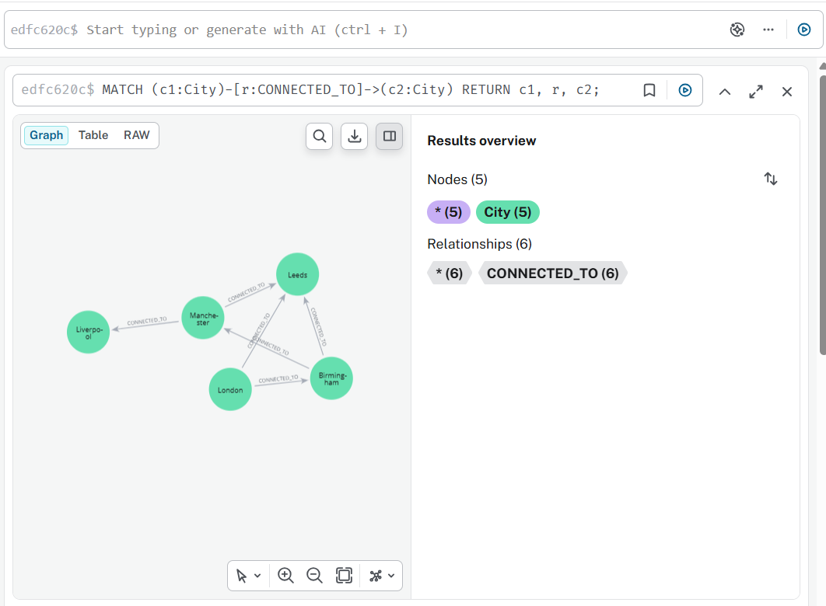

7.2 Find Cities Directly Connected to London
MATCH (:City {name: "London"})-[:CONNECTED_TO]->(city:City)
RETURN city.name AS ConnectedCity;

This query returned:
- Birmingham
- Leeds
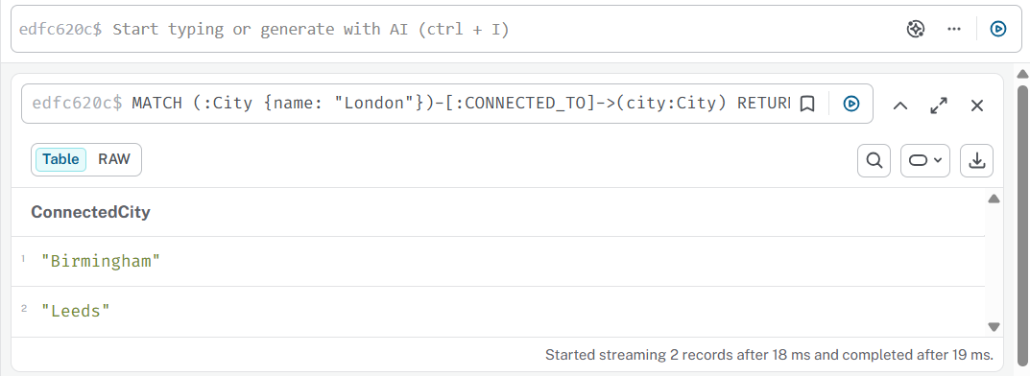

7.3 Find Shortest Path from London to Liverpool
MATCH path = shortestPath(
(:City {name: "London"})-[:CONNECTED_TO*]-(:City {name: "Liverpool"})
)
RETURN path;

This query displayed the shortest path between London and Liverpool.
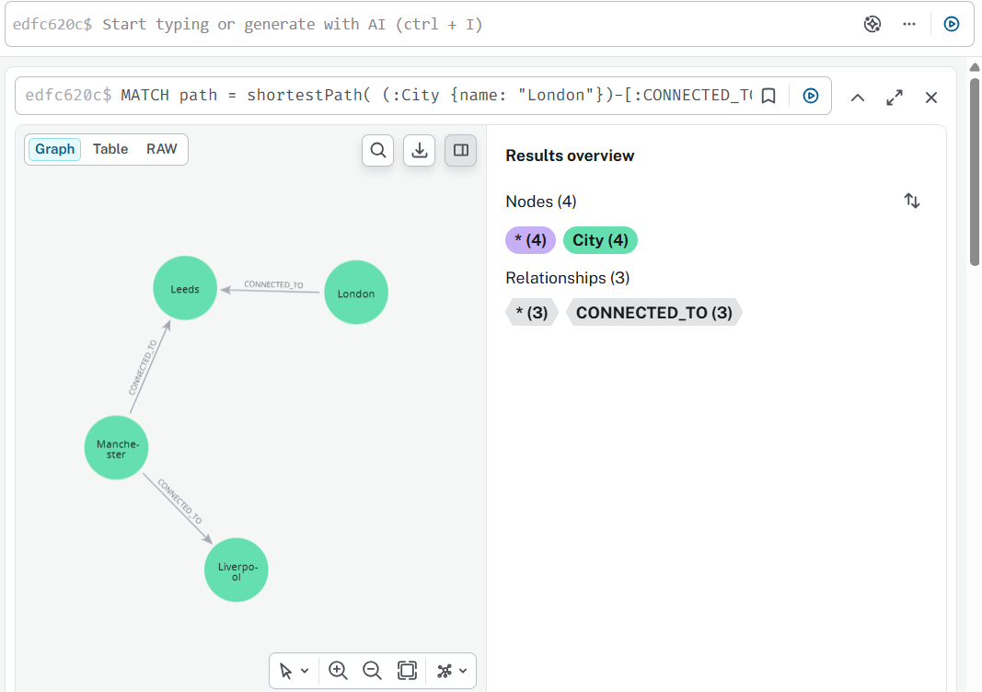

7.4 Find Train Routes Only
MATCH (c1:City)-[r:CONNECTED_TO {type: "Train"}]->(c2:City)
RETURN c1.name AS From, c2.name AS To, r.distance AS Distance;

This query returned only routes where the transport type was Train.
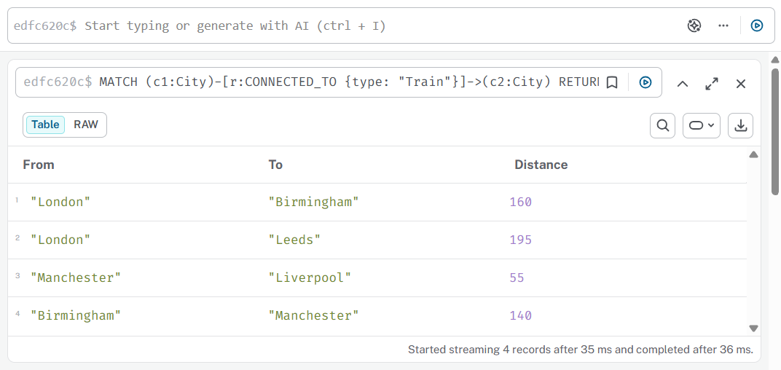

7.5 Find Total Connections per City
MATCH (c:City)-[r:CONNECTED_TO]-()
RETURN c.name AS City, count(r) AS TotalConnections
ORDER BY TotalConnections DESC;

This query counted the total number of connections for each city.
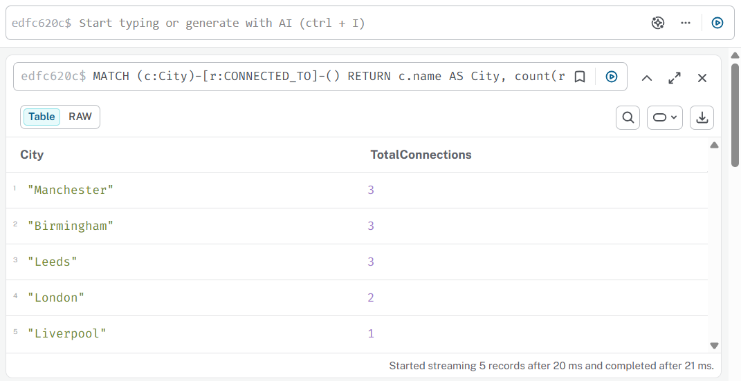

8. Analysis
MongoDB was acceptable for the product review dataset since the data was kept as flexible documents that approximated JSON. The dataset comprised nested data, such as user information, and array data, such as tags. It was now straightforward to query reviews by category, rating, user location, and tags. MongoDB aggregation was also utilized to get the average rating by category.
Neo4j was suited for the transportation network since it centered on the links between cities. The graph technique makes it straightforward to depict cities as nodes and routes as linkages. Neo4j queries were used to determine the most connected cities, train lines, quickest itineraries, and direct links. This illustrates that while MongoDB is useful for document-based data, Neo4j is preferable for relationship-focused data.

